[**https://www.forbes.com/sites/biancamillercole/2020/09/17/8-top-tips-for-improving-your-body-language-during-virtual-meetings/?sh=1f4224251f2a**](https://www.forbes.com/sites/biancamillercole/2020/09/17/8-top-tips-for-improving-your-body-language-during-virtual-meetings/?sh=1f4224251f2a)

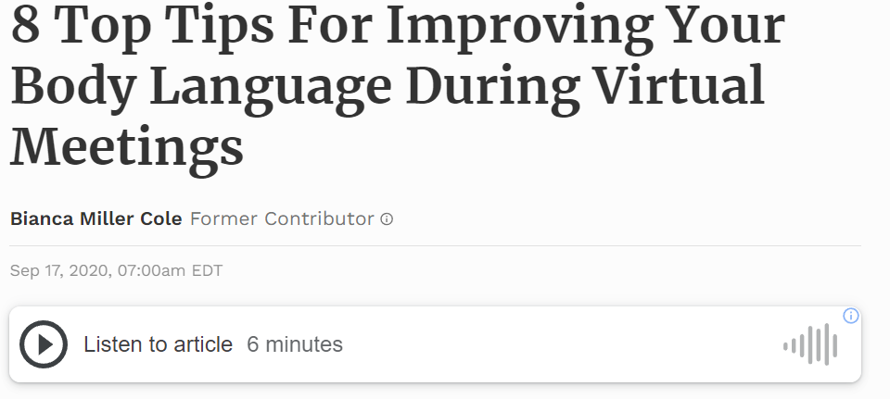

With the pandemic and lockdown in full effect, the world of work has completely changed. Everything is now online, including those virtual meetings you find yourself attending several times a day, every day. Although you are not actively seeing these people face to face, it is still important that your body language is correct and that you are communicating with others in a professional manner. So, here are a few tips and methods on improving your body language.

**1) Posture**

Posture is important! These are some things you shouldn’t do when attending a virtual meeting:

- Don’t lean on the desk. This makes it look as though you are bored and uninterested in the conversation.

- Don’t lean back in your chair as this can seem like you are also unbothered by the conversation and is not very professional.

- Don’t cross your arms as this can mean you are not paying attention to the conversation.

Instead:

- Sit closer to the edge of your seat so you look engaged in the conversation.

- Relax and expand your shoulders to show you are confident and fully engaged in the meeting, boosting your confidence and helping those in the meeting see you are engaged.

**2) Avoid touching the face (and hair ... too much)**

Touching your face throughout the meeting suggests that you are nervous. This includes playing with your hair, itching your noses or chewing your lower lip. You want to avoid these when attending a virtual meeting as you don’t want to **come across as** insecure or nervous!

What you want to do it raise your eyebrows to show interest, nod your head when you agree with what the person says showing that you are actively listening and keep your hands on your lap or use them to write down notes if needed.

**3) Eye contact**

You want to maintain the right amount of eye contact when you attend a virtual meeting. You want to look at those you are speaking to as well as making eye contact directly into the camera lens as this allows the others to see you directly. Eye contact is very important when you are having a face to face meeting so remember that you need to maintain this even though you are not with the people directly.

**4) Smile!**

Make sure to smile when you’re attending virtual meetings. Even if they are with people you already know or a new client or employee, make sure you smile when you greet them. This will enable the conversation to run smoothly and be positive from the start to the finish. But you also don’t want to over smile or not smile at all as it may **come across as** fake if you smile too much or cold if you don’t smile at all. Just remember you want to act as if you were with the person face to face and not treat it like it is virtually through a camera.

**5) Facial expressions**

Facial expressions speak before you even say anything! When attending virtual meetings, avoid frowning, staring or any facial expressions that may have an impact on the conversation and the person you are speaking to. Instead, you want to have a slight smile throughout and also raise your eyebrows a little to show engagement and enthusiasm throughout the conversation. Facial expressions are important as you want the person you are speaking to, to feel comfortable and confident so you have a successful virtual meeting.

**6) Take up space**

You want to take up camera space in a way that makes you look like you are engaged, confident, and communicating effectively in your virtual meeting. To do this you should position yourself close enough to the camera but not too close where it may **come across like** you are invading their personal space.

**7) Pay attention**

Avoid trying to multitask whilst you are attending a virtual meeting, this means not checking your phone or looking around the space that you are in. You want to be focused on the person and engage with them constantly throughout. You do not want it to **come across as though** you are uninterested in the conversation and not paying attention.

**8) Hand gestures**

Use your hands when you are speaking to others throughout the meetings. This makes it seem like you are engaging and enthusiastic about the conversation you are having. Try to avoid remaining still throughout the entire virtual meeting, instead, use your hands when you are counting something or indicating how big or small something is. Simple gestures can be used throughout to make the conversation more natural as though you were speaking face to face.

These are just a few top tips on improving your body language when attending virtual meetings. It isn’t the easiest getting used to having several virtual meetings a day, however as this is the 'new normal' it is essential to consider how much of the work your body language is doing for you during the conversation. It is important to **come across** **as** confident and engaging with the people you are speaking to. Keep these in mind for the next virtual meeting you may have (which is probably happening tomorrow morning!)